Redis 3.2 ON Linux RHEL 7

**Install Redis 3.2**

For installing Redis 3.2 you have to download the source file and compile it because Redis 3.2 is not available in any repository yet.

On CentOS 6 and CentOS 7

yum install wget make gcc tcl

wget http://download.redis.io/releases/redis-3.2.8.tar.gz

Now you have to extract the file that you just downloaded by typing:

tar -xvzf redis-3.2.8.tar.gz

Change directory with the command below:

cd redis-3.2.8

It’s time to compile your Redis step by step:

cd deps

make hiredis lua jemalloc linenoise

make geohash-int

Now run below command to get back to the parent directory and run the next command:

cd ../

make

make install

And for getting sure running a test:

make test

It’s going to take a few minutes, you can check that everything is ok.

**Install init script**

In this section, we are going to install “init script” to manage the process of Redis.

cd utils

./install_server.sh

[root@ip-10-10-0-26 utils]# ./install_server.sh

Welcome to the redis service installer

This script will help you easily set up a running redis server

Please select the redis port for this instance: [6379]

Selecting default: 6379

Please select the redis config file name [/etc/redis/6379.conf]

Selected default - /etc/redis/6379.conf

Please select the redis log file name [/var/log/redis_6379.log]

Selected default - /var/log/redis_6379.log

Please select the data directory for this instance [/var/lib/redis/6379]

Selected default - /var/lib/redis/6379

Please select the redis executable path [] /usr/local/bin/redis-server

Selected config:

Port : 6379

Config file : /etc/redis/6379.conf

Log file : /var/log/redis_6379.log

Data dir : /var/lib/redis/6379

Executable : /usr/local/bin/redis-server

Cli Executable : /usr/local/bin/redis-cli

Is this ok? Then press ENTER to go on or Ctrl-C to abort.

Copied /tmp/6379.conf => /etc/init.d/redis_6379

Installing service...

Successfully added to chkconfig!

Successfully added to runlevels 345!

Starting Redis server...

Installation successful!

[root@ip-10-10-0-26 utils]#

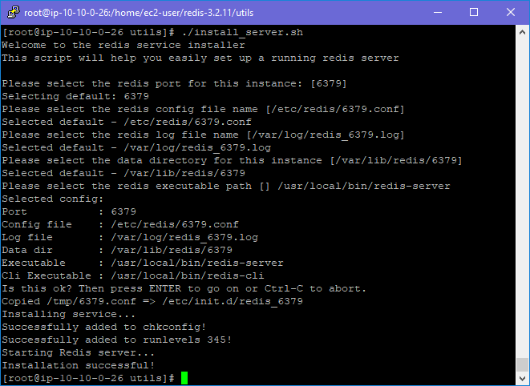

You will be prompt for some configuration you can hit “Enter” to accept all the default values or you can set yours.

Finally, your Redis server is installed and you can start the service by the command below:

For CentOS 6

service redis_6379 start

For CentOS 7

systemctl start redis_6379

If you want to test your Redis server you can easily use the instruction below:

redis-cli

> set test "HugeServer"

> get test